Workflow Functional Document

Application: | NGERP-CENTRA
WorkFlow: | Move To Stock
WorkFlow Item Name: | UnPackage Production

Description:

This function is used to unpack the bom products with its inventory detail like lot and qty into the NGERP system.The packed product or packed goods may splited and moved to single unit of product moved to its orignal storage.

Work Flow Process:

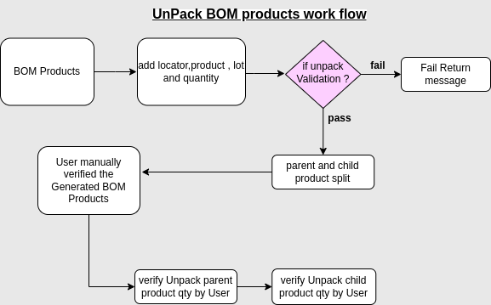

Business Rule:

- Before unpack the BOM products need to validate expiry date of product.
- Add locator for unpack the Packed BOM Product in ROW.
- add attribute set instance (Lot) to the unpack packed products .
- Add qty from packed to unpack its original products.
- Lot expiry Date automatically choose by system based on the parent lot no.
- process allow to unpack bom products and split into parent and child products qty added in its original storage.
- Parent and child qty and lot verified by user manually after unpack the products.

